
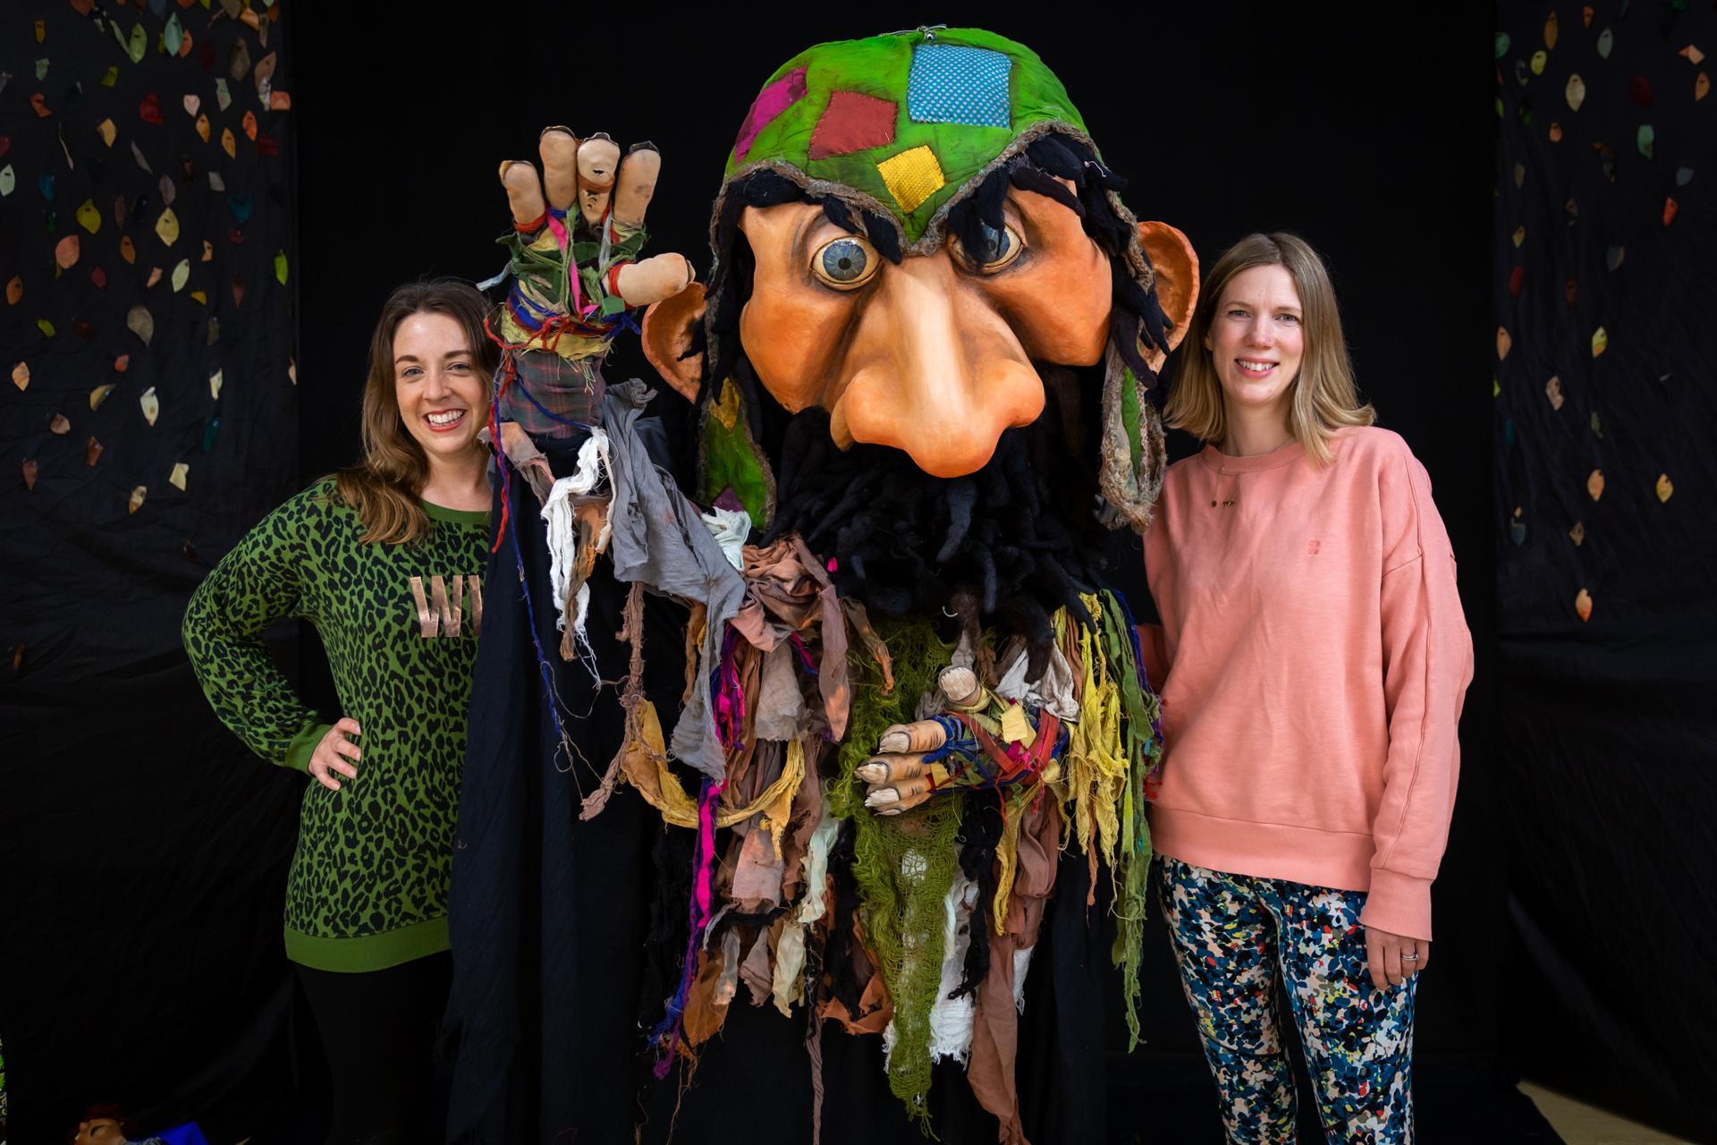
Dear Parents and Carers,
As I’m sure you will be aware, your child has recently participated in our “The Fearsome Giant” theatre production and arts workshop. We wanted to write to you to involve you in their learning and provide you with some resources that might help you address issues of anxiety and worry with your children at home.
The children loved watching the storytelling puppet show by The Theatre of Widdershins and so we would love you to enjoy the production and encourage your child/children to watch it again with you. Please click the link to view the production of "The Fearsome Giant".In response to the production, we encouraged the children to recognise what fear/anxiety looks like and how it feels in their bodies, so that they can manage their feelings better. We encouraged them to: talk to someone about their worries; practise mindful/calm breathing and use their sensory nest. Your child will have brought home a sensory nest - this was developed in conjunction with an art therapist to help children manage episodes of worry or anxiety. Watch this video to find out how to use the sensory nest with your child.
At the end of our sessions we shared some fantastic children’s stories which explore these issues so well. Listen to these again with your children through our you-tube channel:
Ruby's worry
The Huge Bag of Worries
All links will be live for the next month, so please do take advantage of your access to these resources.
There are many ways to help manage anxiety with your children - why not check out the ‘videos’ on our instagram page - we released a series on this topic in early September - Video 1 of 5
We also have a parenting programme which helps you develop tools and strategies to support your child’s emotional wellbeing, as well as support for you to manage your own anxiety in parenting. If you are interested in these, please do get in contact with us - talktous@theconversationstamford.co.uk
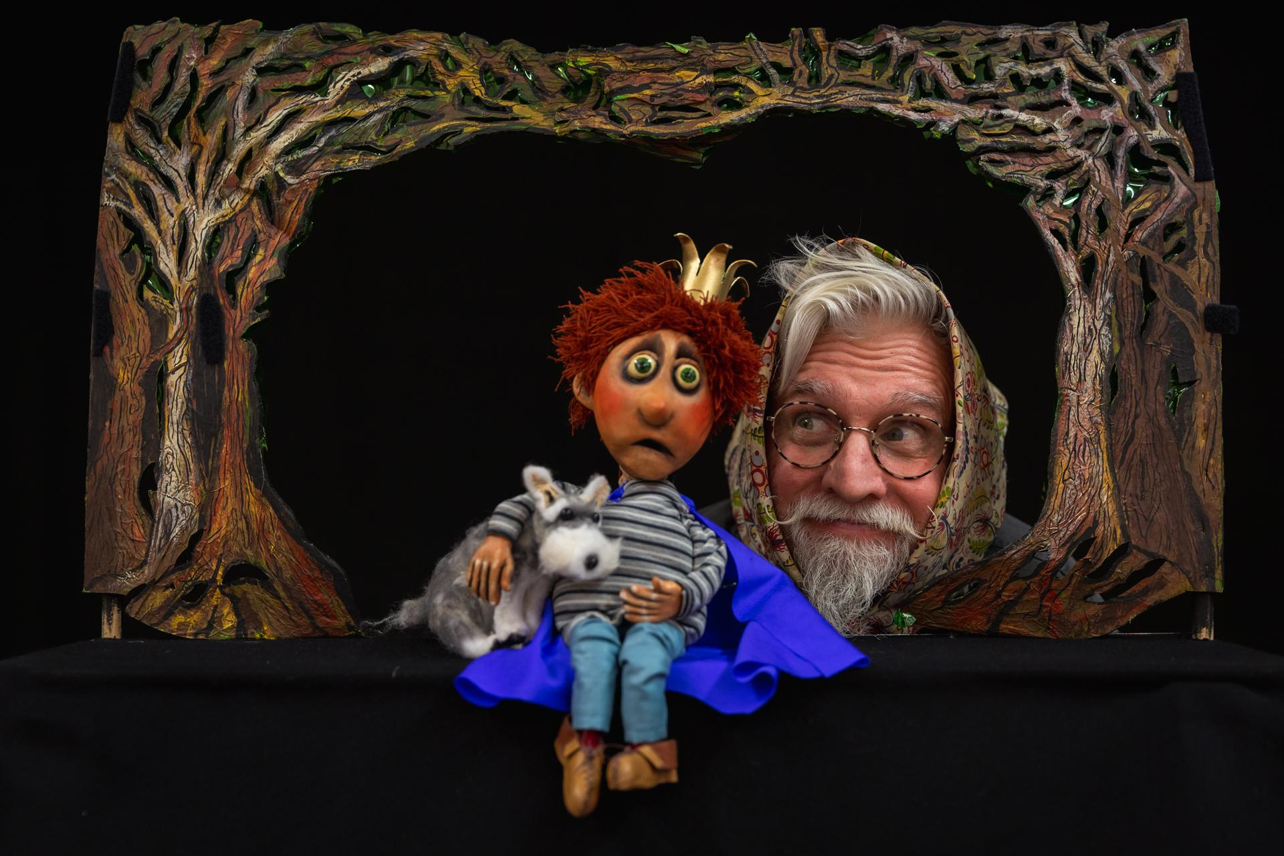
Do let us know your thoughts and comments on the production and workshop, and follow us on social media to keep up to date with what we are doing with children, young people and parents.
Many thanks,
Gemma Holbird and Sarah Jane Sauntson
(Directors of The Conversation Stamford)
Find us on: 

