HOLIDAY CLUB BOOKING FORM
FEBRUARY 2025

Acorn Childcare Centre is pleased to be running February Holiday Club every day between 17 February 2025 and 21 February 2025.
Please see below the terms and conditions of booking:
- Bookings are to be made by using the form below. Please tick the day and session required and return via email to enquiries@acornchildcarecentre.co.uk
- The two session times will be 0900to 1500, or 0730 to 1800. You will be able to drop and collect children at any time during the longer day session, but you will be charged for the full day.
- 48 hours’ notice is required when cancelling sessions (weekends are not included in the 48 hours).
- All meals/snacks are provided except for lunch so please send in a healthy packed lunch for your child each day. Drinking water will be provided at all times of the day and therefore no other drinks will be needed.
- We must hold a current admission form and a deposit for each child before they can attend. Admission forms can be requested at the Acorn office or via email.
- The 0900-1500 session will be run to this exact start and end time. If you require extra time around this session, please book the longer day to accommodate your childcare needs.
- Sessions will be charged as follows: 0900-1500 = £28.00 and 0730-1800 = £44.00.
Any primary-aged child is welcome to attend our holiday club, even if they do not attend Malcolm Sargent Primary School, providing they are registered with Acorn before attending.
The below timetable is in addition to all our usual activities including pool table, table tennis, air hockey, Lego, small world play, arts and crafts, and football, cricket, basketball, giant games, and lots more!
All inside activities are subject to change depending on weather conditions.

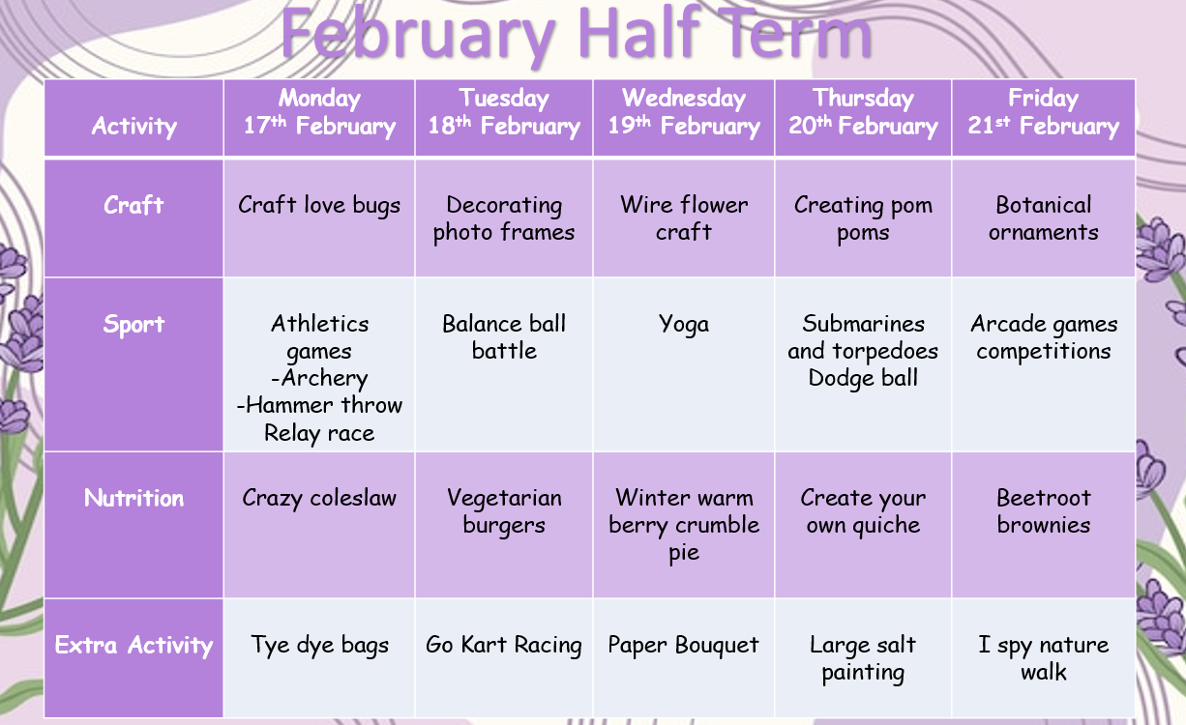

HOLIDAY CLUB BOOKING FORM
Please tick the day and session you require and return this form to enquiries@acornchildcarecentre.co.uk or drop in to the Acorn office.

Child/Children’s Name(s):
Parent Name:
Child/Children’s Year Group(s):

Day | 0900-1500 Session | 0730-1800 Session
Monday 17th February

Tuesday 18th February
Wednesday 19th February
Thursday 20th February
Friday 21st February

