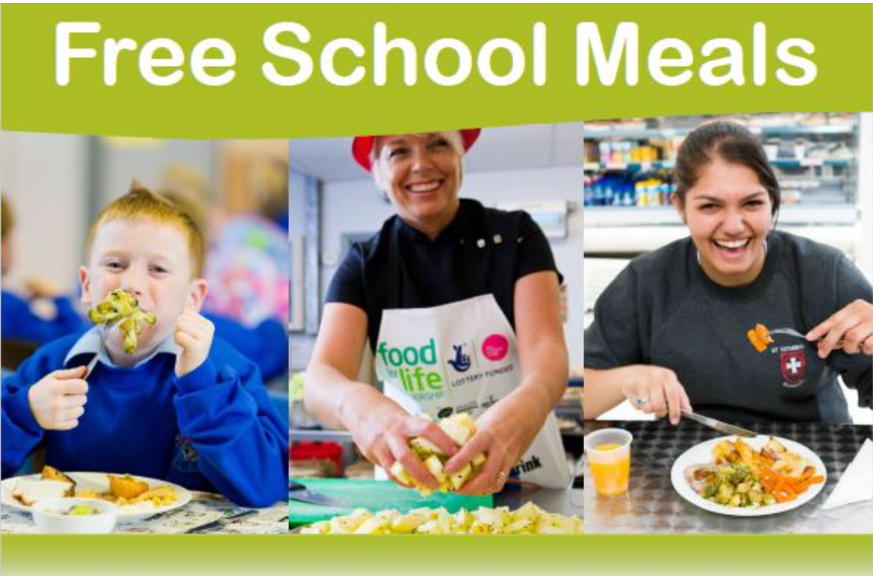
- Do you receive any of the following benefits?
- Income Support
- income-based Jobseeker’s Allowance
- income-related Employment and Support Allowance
- support under Part VI of the Immigration and Asylum Act 1999
- the guaranteed element of Pension Credit
- Child Tax Credit (provided you’re not also entitled to Working Tax Credit and have an annual gross income of no more than £16,190)
- Working Tax Credit run-on - paid for 4 weeks after you stop qualifying for Working Tax Credit
- Universal Credit - if you apply on or after 1 April 2018 your household income must be less than £7,400 a year (after tax and not including any benefits you get)


If so, you may be entitled to free school meals which can then also give your school additional funding (called Pupil Premium) for the next six years to help support your child. You will also be eligible for any Household Support Fund vouchers made available via LCC (last summer this was for £90 per child) and free entry to the Holiday Activities & Food Club (HAF Club) run every long holiday by Acorn Childcare Centre which includes a free hot meal daily.

SCAN THE QR CODE TO APPLY

or visit www.lincolnshire.gov.uk/school-pupil-support/apply-free-school-meals
The school office team will be happy to help you discreetly apply if you are unsure what to do

