22 January 2026

Dear Parents/Carers

YEAR 5 AND YEAR 6 YOUNG VOICES CHOIR – MONDAY 26 JANUARY 2026 – BP PULSE LIVE ARENA, BIRMINGHAM – IMPORTANT INFORMATION - PLEASE READ CAREFULLY

It’s finally here! We are all very excited to be taking part in the Young Voices 2026 concert. Here is a reminder of what will happen on the day and what the children will need to bring with them.

**** IMPORTANT INFORMATION REGARDING FOOD ALLERGIES ****
A child attending this concert has a severe airborne fish allergy. To ensure everyone can attend safely, we kindly ask that no items containing fish are brought into the venue on this day, including families attending the concert.
This includes, but is not limited to:
- Fish or seafood sandwiches
- Prawn cocktail crisps
- Any snacks or meals containing fish products
Can I also remind you that we have children with NUT ALLERGIES and therefore no items containing nuts should be brought onto the trip or into the arena and no food should be shared.

What to Wear
On the day, the children should come to school in their Young Voices t-shirt, if ordered, or a plain white t-shirt (no logos including school logos or pictures) or a previous year’s Young Voices t-shirt. If you wish, your child may change into their t-shirt at the arena prior to the concert and you are welcome to pack a change of clothes if you feel this is appropriate, They are welcome to wear a hoodie, school hoodie is fine, or jumper over their t-shirts, this will need to be removed for the concert.

T-Shirts from home cannot be decorated to look like an official Young Voices t-shirt.

There is a limited number of spare Young Voices t-shirts from a previous year which your child may borrow, on request.

In previous years, t-shirts have been available to purchase at the arena. Please bring £22 (cash only) in a sealed envelope with your child’s name written on it and ‘T-shirt money’ but it is not guaranteed there will be any t-shirts on sale.

They should also wear dark coloured, comfortable bottoms (school trousers, leggings, dark jeans, trousers or jogging bottoms), comfortable shoes (ie trainers) as we will be standing for some time) and a coat.

Travel Sickness and Other Medication
If your child requires travel sickness medication, please ensure that you inform the office ASAP. Please give the medication to Mrs Mills in a clearly named envelope with the time it needs to be given in the morning and the evening return journey.

If your child has asthma or needs an AAI, we will be taking these with us if they are in school.

For any other medical needs, please inform Mrs Mills.

Tickets
The tickets have been transferred to your AXS account if you have ordered audience tickets. Please check that you have received them and let the office know if you haven’t.

Timings of the Day
The children will leave school at 1115 to get to Birmingham. The coaches will return to school after the concert, when you will be able to pick up your child, at approximately 2245, depending on traffic. Please do not park in the lay-by in front of school as that is where the coach will park. If we are running early/late we will contact you via a ParentMail text. For that reason, please ensure that your contact details are up to date on ParentMail.

- 1115 depart
- 1300 lunch at the arena
- 1345 take our places in the arena
- 1415 rehearsal starts
- 1700 tea
- 1800 back in seats and audience members are allowed in
- 1900 concert commences
- 2045 concert ends
- 2245 approximate return to school
If you have not already done so, please make sure you pay for the coach, via ParentMail Payments, by 1000 on Friday 23 January 2026 or your child may not be able to join this trip.

Food and Snacks
It is a long day so do please provide your child with lots of healthy snacks to keep them going through the day and lots of water or healthy drinks in a plastic bottle. Glass bottles and cans are not permitted in the arena.

The children will need to bring a packed lunch AND a packed tea in separate bags and make sure your child knows which bag is for lunch and which for tea!

Food should be placed in a rucksack or small bag that can be easily stored away under their seat in the arena.

If your child is entitled to a Free School Meal and you would like the school to provide lunch, please contact Mrs Bell immediately as we are supposed to give the kitchen one week’s notice of FSM packed lunches. Please note that you will still need to provide a packed tea, drinks and snacks which are not provided as part of the FSM lunch.

PLEASE REMEMBER NO PRODUCTS CONTAINING FISH OR NUTS.

Mobile Phones
Your child will not need a mobile phone for the trip. If they bring them to school, they should not put them into the class bag but tell an adult in class so that a staff member on the trip can look after them and return them to the relevant children at the end of the day.

Information from Young Voices
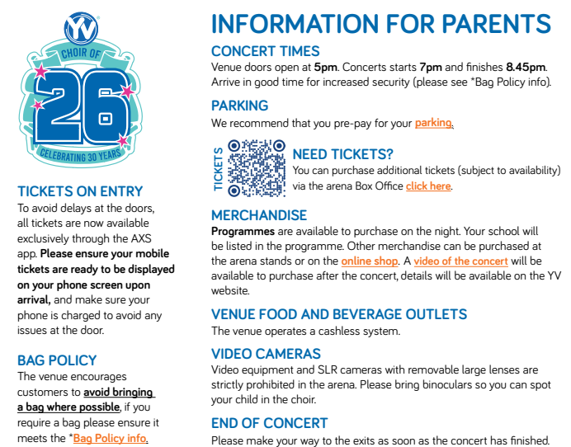

… And Finally

Children should have plenty of rest over the next couple of days to keep their energy levels up as it is a busy, late and tiring, but really exciting day of singing. Keep practising the songs and dance moves! The Young Voices playlist is available on Spotify with a free account and in the Young Voices Music Room if you have an account.

The most important thing is to have a fantastic time and if you are coming to watch the show, I hope you have great time!

If you have any further questions or queries, please contact me.

Yours sincerely

Mrs Vicki Mills
Music Subject Leader

