RISK ASSESSMENTS PROCEDURE
SEPT 2025-SEPT 2026

What is a Risk Assessment?
A risk assessment is the combined effort of:

- Identifying and analysing potential events that may negatively impact individuals, assets, and/or the environment and
- Making judgments on the tolerability of the risk on the basis of a risk analysis while considering influencing factors.

So, a risk assessment is a document written to identify any hazards or risks within or outside school (physical or as part of a lesson or activity) and a scheme to preferably eliminate the risk entirely. If the risk cannot be eliminated, it must be reduced to an acceptable level.

The risk assessment is scored to ensure that the severity of injury multiplied by the likelihood of injury are reduced to acceptable level. For instance, using the scoring below, if the severity of injury is catastrophic (5) and the likelihood of occurrence is almost certain (5), that would give a risk assessment score of 25 which is entirely inappropriate:

Severity of Injury 1 minor / 2 moderate / 3 significant / 4 major / 5 catastrophic
Likelihood of Occurrence 1 rare / 2 unlikely / 3 moderate / 4 likely / 5 almost certain

In school, we consider a score of less than 10 to be acceptable, from a maximum total of 25. Usually, our risk assessments score around 3-6 with some activities, such as swimming or the residential trip to PGL for the Y6 children, being the highest scoring.

All risk assessments are reviewed annually or on change either by the Business Director or the Site Manager, and often in conjunction with another staff member ie DT Lead for DT activities etc.

List and Location of Risk Assessments
The school has a standard bank of risk assessments which cover all regular activities in school as well as those which have been written for single activities.

All risk assessments are available from S:/Administration/H&S/Risk Assessments - Current.

The list of risk assessments currently available is:

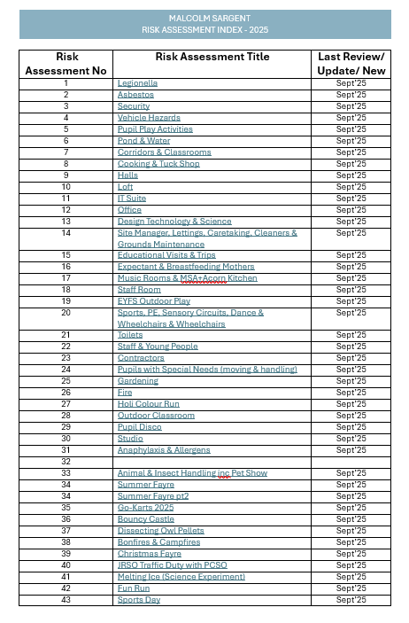

NB: The Swimming RA is generic, and a specific trip risk assessment must be written and signed off by the Educational Visits Coordinator and Principal in advance of trips for swimming lessons taking place.

Additional/New Risk Assessments
If a risk assessment is not in place for a new activity, the activity leader must meet with the Business Director to write a new assessment in advance of the activity taking place. Once agreed, it must be shared with all staff members who are to be involved in the activity, giving them sufficient notice to query any parts of the assessment.

If the risk cannot be sufficiently reduced for all or any part of an activity, the activity will not take place.

Responsibility of Staff Members
It is the individual responsibility of each staff member to familiarise themselves with the location and content of each risk assessment applicable to them and to follow the strategies laid out in each assessment. Failure to do so could result in disciplinary action.

Any questions must be directed to the Business Director in the first instance.

