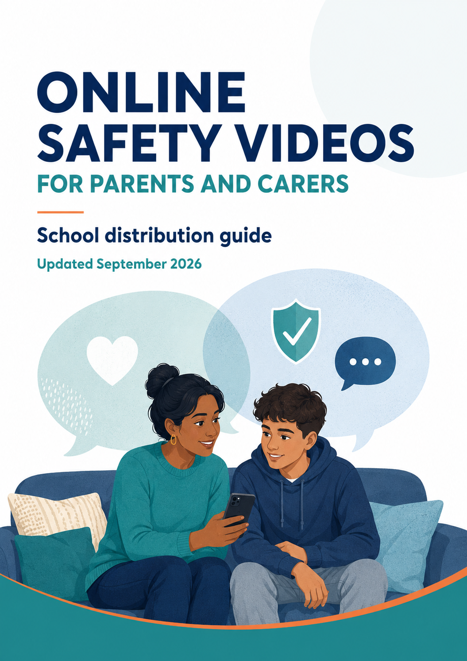

Introduction
VIDEO 1 OF 7 | VIDEO LENGTH 7 minutes

COPY FROM HERE
Welcome to the first video in this online safety series.
Whatever the age of your child, they will receive online safety education in school, from the early years through to college. However, as parents and carers, we also need to understand and keep up with the risks and issues children may face online. Just as importantly, we need to know where to go for additional support.
My name is Alan Mackenzie. I specialise in the ever-changing area of online safety, working mainly with schools across England. In this first video, I'll introduce myself and explain what online safety means.
Over the coming weeks, you will receive six more messages from school, each with a link to a new video and some accompanying text including useful links to free information and resources.
Video link:
https://vimeo.com/1220548611/5b9f9abedb
COPY TO HERE

Online Life
VIDEO 2 OF 7 | VIDEO LENGTH 19 minutes

COPY FROM HERE
Welcome to the second video in this online safety series.
Today we'll take a brief look at what children and young people are doing online, and why.
Use the link below to watch the video. You will also find several useful links that are mentioned in the video.
Video link:
https://vimeo.com/1220549479/6f3919dcee
Useful links:
Internet Matters: Digital Family Agreement
https://www.internetmatters.org/resources/digital-family-agreement-template/
YouTube Supervised Experience
https://support.google.com/youtube/answer/10314940?hl=en-GB
A guide to the YouTube Kids app
https://www.youtube.com/kids/
YouTube Kids: how to approve content
https://www.youtube.com/watch?v=NtrlvqztMcQ
COPY TO HERE

Risk and Harm
VIDEO 3 OF 7 | VIDEO LENGTH 13 minutes

COPY FROM HERE
Welcome to the third video in this online safety series.
Today we're going to consider risk and harm. Risk is the likelihood that harm may occur, and certain factors can increase or reduce that risk. We'll also look at the 4Cs: Content, Contact, Conduct and Commerce. The 4Cs provide a straightforward way to understand online risk, whether or not you consider yourself tech-savvy.
Video link:
https://vimeo.com/1220552061/433c4146b4
Useful links:
Misleading app age ratings report
https://5rightsfoundation.com/apple-and-google-expose-children-to-data-privacy-breaches-through-misleading-app-age-ratings/
Common Sense Media reviews
https://www.commonsensemedia.org
Internet Matters: parental controls guides
https://www.internetmatters.org/parental-controls/
Snapchat Family Centre
https://help.snapchat.com/hc/en-gb/articles/7121384944788-What-is-Family-Centre
TikTok Family Pairing
https://support.tiktok.com/en/safety-hc/account-and-user-safety/family-pairing
Google Family Link
https://support.google.com/families/answer/7101025?hl=en
Roblox parental controls
https://en.help.roblox.com/hc/en-us/articles/30428310121620-Parental-Controls-Overview
COPY TO HERE

Online Influence
VIDEO 4 OF 7 | VIDEO LENGTH 12 minutes

COPY FROM HERE
Welcome to the fourth video in this online safety series.
In this video, we're looking at online influence. As children grow, the digital environments around them evolve too, often alongside their changing interests and behaviours. What are some of the factors that can influence children online?
We'll also take a brief look at misogyny.
Use the link below to watch the video.
Video link:
https://vimeo.com/1220554199/a583619ae1
Useful links:
What is a parasocial relationship?
https://www.internetmatters.org/hub/news-blogs/what-are-parasocial-relationships/
The online disinhibition effect
https://ed.buffalo.edu/content/dam/ed/alberti/docs/conference/Levy%20Presentation%202014%20.pdf
What are algorithms?
https://www.internetmatters.org/hub/news-blogs/what-are-algorithms-how-to-prevent-echo-chambers/
What is persuasive design?
https://saferinternet.org.uk/blog/talking-to-young-people-about-persuasive-design
What is misogyny?
https://www.internetmatters.org/issues/online-hate/what-is-misogyny/
COPY TO HERE

Exploitation
VIDEO 5 OF 7 | VIDEO LENGTH 10 minutes

COPY FROM HERE
Welcome to the fifth video in this online safety series.
This video covers a difficult subject: the increasing number of children being exploited online, including sextortion (financially motivated sexual extortion). This is an important area for every parent and carer to understand.
I don't go into graphic detail; the focus is on statistics and emerging issues. Even so, please consider your own wellbeing before watching, be aware of who may be able to hear the video, and consider using headphones.
Video link:
https://vimeo.com/1220189734/7f1bb91a2e
Useful links:
Internet Watch Foundation: TALK checklist - clear, practical advice to help keep children safe
https://talk.iwf.org.uk/wp-content/uploads/2022/03/Parent-Resource.pdf
Internet Watch Foundation: supporting children with SEND
https://talk.iwf.org.uk/children-with-send/
Child Exploitation and Online Protection (CEOP)
https://www.ceop.police.uk/Safety-Centre/
IWF and Childline: Report Remove - for young people who have shared a nude image
https://www.childline.org.uk/info-advice/bullying-abuse-safety/online-mobile-safety/report-remove/
Internet Matters: teens, sexting and risks
https://www.internetmatters.org/about-us/sexting-report-look-at-me/
COPY TO HERE

Artificial Intelligence
VIDEO 6 OF 7 | VIDEO LENGTH 12 minutes

COPY FROM HERE
Welcome to the sixth video in this online safety series.
Artificial intelligence isn't new, but generative artificial intelligence (generative AI) is now widely available. It offers enormous possibilities, but there are also significant risks.
In this video, we'll take a brief look at artificial intelligence and consider a few examples of potential risk.
Video link:
https://vimeo.com/1220556501/51f900c3fe
Useful links:
A parent's guide to AI
https://www.internetmatters.org/resources/parent-guide-to-artificial-intelligence-ai-tools/
Me, Myself and AI: chatbot research
https://www.internetmatters.org/hub/research/me-myself-and-ai-chatbot-research/
AI companion bots: understanding the risks posed to young users
https://voicebox.site/article/ai-companion-bots-and-explicit-images-understanding-risks-posed-young-users
COPY TO HERE

Final Notes
VIDEO 7 OF 7 | VIDEO LENGTH 5 minutes

COPY FROM HERE
We've reached the final online safety video in this series. This is a short wrap-up with some final advice. Throughout the previous messages, I've shared tips and links to other useful information; you'll find a few more below.
Video link:
https://vimeo.com/1220189736/0c82ba70d8
Useful links:
Internet Matters - information about common risks, parental controls, gaming, social media, additional needs, screen time and much more
https://www.internetmatters.org
Common Sense Media - reviews and information about apps, games, films, books and more
https://www.commonsensemedia.org
Child Exploitation and Online Protection (CEOP) - report concerns about the way someone has been communicating with a child online
https://www.ceop.police.uk/Safety-Centre/
Kids, Puberty and Tech - conversation starters for 8- to 12-year-olds
https://parents.thorn.org/situation/
Discussion guides for 7- to 17-year-olds, covering device access, consent, friendships and more
https://parents.thorn.org/discussion-guides/
COPY TO HERE

